# Customer Satisfaction Analysis Report

Project Title: Analyzing ticket trends, resolution efficiency, and customer satisfaction

Tools: A Comprehensive Analysis Using Excel, Pandas and Power BI

Submitted by: Mumtaj

**📌 Introduction**  
This project focuses on analyzing customer support ticket data to uncover patterns in ticket volume, resolution times, ticket types, and customer satisfaction ratings. By leveraging **Excel**, **Pandas (Python)**, and **Power BI**, the analysis provides data-driven insights into operational performance. The goal is to identify inefficiencies, track service trends, and highlight areas for improving customer experience and resolution efficiency.

**📌 Objectives**

1. **Analyze ticket trends** – Understand the distribution of tickets by type, priority, and status.
2. **Measure resolution efficiency** – Evaluate average resolution time and identify delays.
3. **Assess customer satisfaction** – Review ratings to detect strengths and weaknesses in service delivery.
4. **Identify peak periods** – Determine when ticket volumes are highest to optimize staffing.
5. **Support decision-making** – Provide actionable insights to enhance operational performance and customer experience.

**Dataset Overview**

The dataset contains detailed records of customer support interactions, covering ticket creation, resolution, and feedback. It includes key attributes such as:

* **Ticket ID** – Unique identifier for each customer support case.
* **Date Created** – The date the ticket was opened.
* **Ticket Type** – Category of the issue (e.g., Technical, Billing, General Inquiry).
* **Priority Level** – Urgency of the ticket (High, Medium, Low).
* **Assigned Agent** – Support staff handling the ticket.
* **Resolution Time (Hours)** – Time taken to resolve the ticket from creation to closure.
* **Status** – Current state of the ticket (Open, In Progress, Resolved, Closed).
* **Customer Satisfaction Rating** – Feedback score provided by the customer after resolution.

The dataset was analyzed using **Excel** for initial cleaning and summarization, **Pandas (Python)** for deeper statistical analysis, and **Power BI** for creating interactive visual dashboards.

**Data Cleaning:**  
The dataset was cleaned in Excel to ensure accuracy and consistency. Steps included removing duplicate rows, correcting spelling errors, standardizing date formats, filling or removing missing values, and ensuring consistent categories (e.g., ticket type names). This process prepared the data for accurate analysis and visualization.

**Exploratory Data Analysis (EDA):**

After cleaning the dataset using Excel and importing it into Pandas:

**1️⃣Ticket Status Distribution**

**Objective:**  
To analyze the distribution of customer support tickets across different statuses (Open, Closed, Pending Customer Response) in order to understand workload balance, resolution rates, and potential bottlenecks in the support process.

**Analysis:**

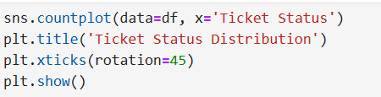

**Insight**: 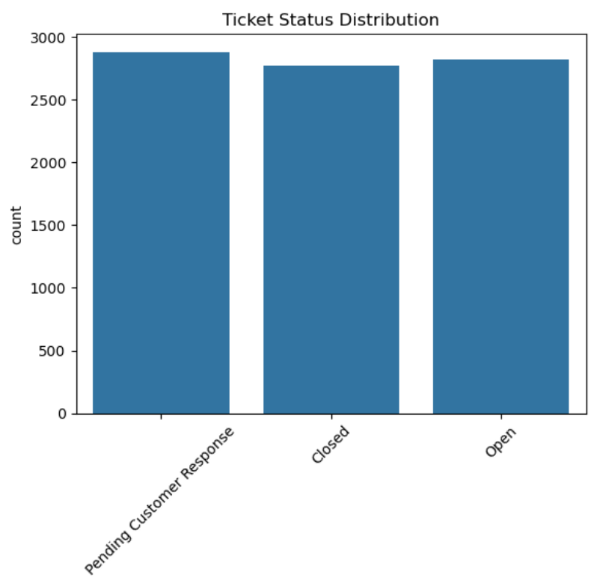

The dataset contains a fairly even distribution of tickets across all statuses, with a slightly higher number of cases pending customer responses. This suggests that while ticket closure rates are healthy, a noticeable portion of tickets remains in a pending state, potentially indicating delays in customer follow-ups.

**2️⃣Ticket Priority Distribution Analysis**

**Objective:**  
To examine the distribution of customer support tickets based on their priority levels (Critical, High, Medium, Low) to understand workload urgency and resource allocation needs.

**Analysis:**

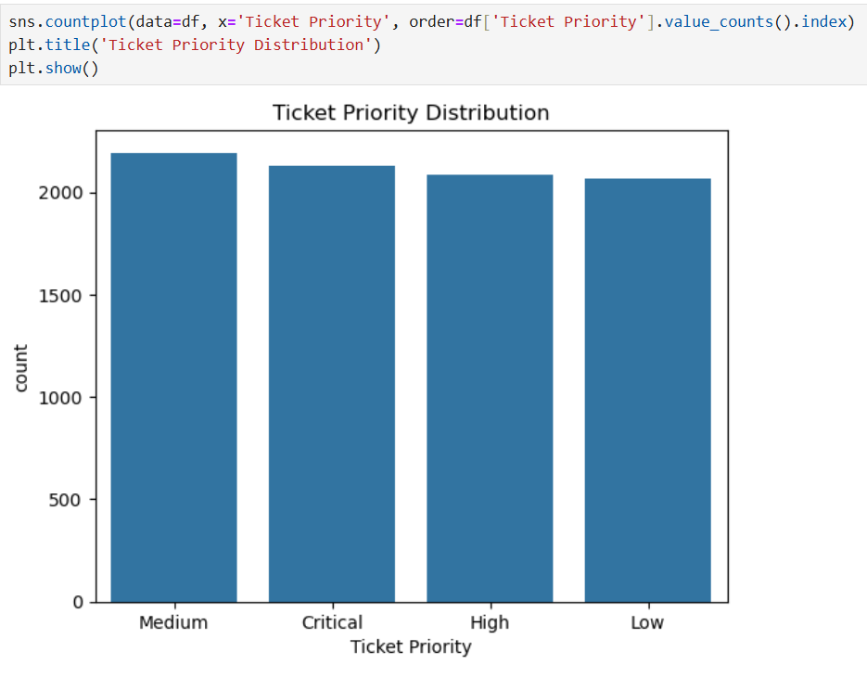

**Insight:**  
The ticket priorities are fairly balanced across all categories, with *Medium* priority tickets slightly higher in count compared to others. This suggests that the support team deals with a relatively even mix of urgency levels, allowing for a more consistent workflow without extreme spikes in critical cases.

**3️⃣Ticket Channel Usage**

**Objective:**  
To understand the distribution of support tickets across different communication channels (Email, Phone, Social Media, Chat) and identify customer preferences for reaching support.

**Analysis:**

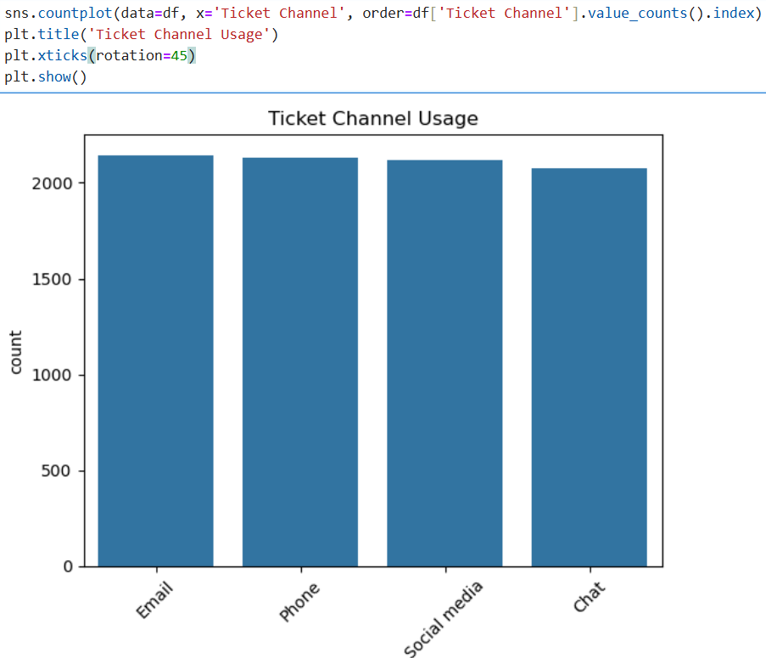

**Insight:**  
All four channels show a relatively balanced usage, with *Email* being the slightly more preferred method, followed closely by *Phone* and *Social Media*. *Chat* has the lowest count but is still close in volume, indicating that customers use all available channels almost equally, suggesting the need to maintain consistent service quality across all platforms.

**4️⃣Satisfaction Rating by Ticket Priority**

**Objective:**  
To examine how customer satisfaction ratings vary based on the priority level of their support tickets (Critical, High, Medium, Low) and identify if urgency impacts satisfaction levels.

**Analysis:**

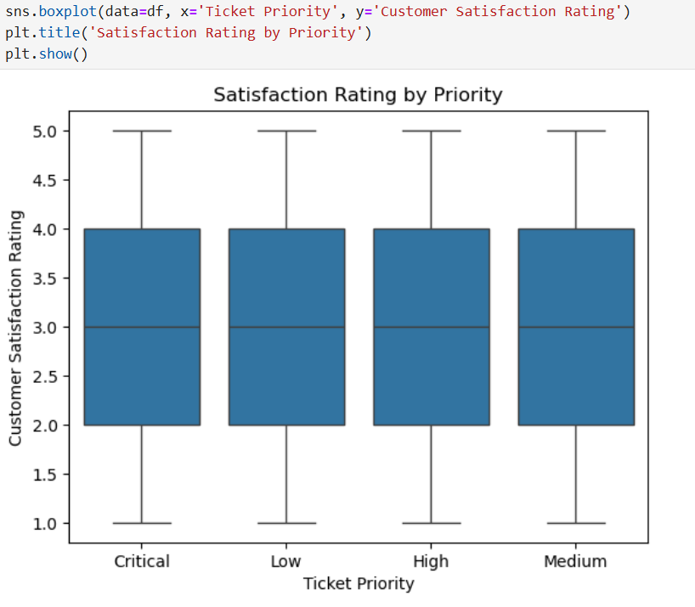

**Insight:**  
The median satisfaction rating is consistent across all priority levels (around 3), suggesting that ticket priority does not significantly influence customer satisfaction. However, ratings show a wide spread (from 1 to 5) in all categories, indicating that other factors beyond priority likely play a bigger role in determining satisfaction.

**5️⃣Resolution Time vs Customer Satisfaction**

**Objective:**  
To investigate the relationship between ticket resolution time (in hours) and customer satisfaction ratings, while considering ticket priority as a factor.

**Analysis:**

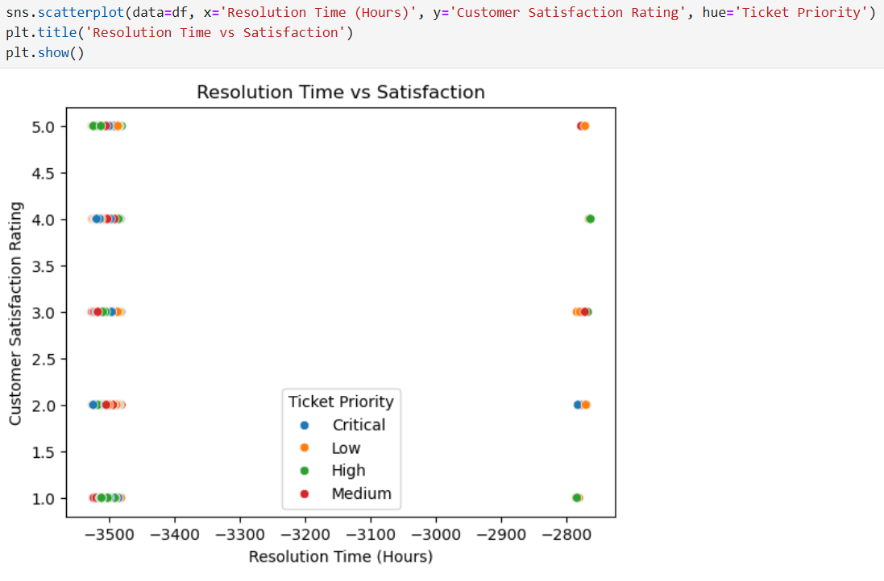

**Insight:**  
The scatterplot shows no clear trend between resolution time and satisfaction rating—satisfaction ratings vary widely regardless of how long the resolution took. Additionally, ticket priority (Critical, High, Medium, Low) does not appear to significantly alter this relationship. The unusual negative resolution times suggest data quality issues that should be addressed before drawing stronger conclusions.

**6️⃣Average Customer Satisfaction by Ticket Type**

**Objective:**  
To determine which types of customer service tickets receive the highest average satisfaction ratings, helping to identify areas of strength and improvement in service delivery.

**Analysis:**

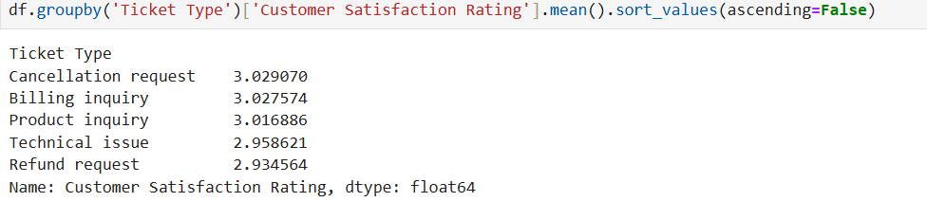

**Insight:**  
The highest satisfaction ratings are seen for *Cancellation requests* (3.03), *Billing inquiries* (3.03), and *Product inquiries* (3.02). Lower satisfaction is observed for *Technical issues* (2.96) and *Refund requests* (2.93), indicating these areas may require process improvements or better customer handling to boost satisfaction.

**7️⃣Ticket Volume by Status and Type**

**Objective:**  
To analyze the distribution of customer service tickets across different ticket types and statuses, identifying workload patterns and potential backlogs.

**Analysis:**

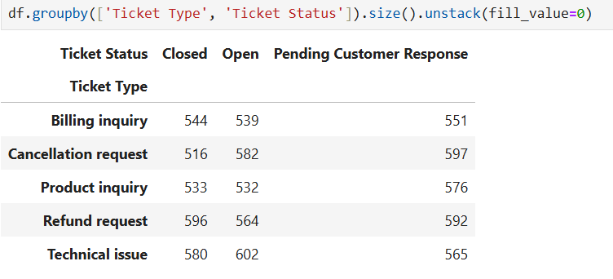

**Insight:**  
"Technical issue" tickets have the highest number of open cases (602), suggesting possible delays or complexity in resolution. "Cancellation request" and "Refund request" also show high pending customer responses (597 and 592 respectively), indicating follow-up bottlenecks. In contrast, "Billing inquiry" tickets have a relatively balanced distribution across statuses, suggesting smoother handling.

**Power BI Dashboard Overview**

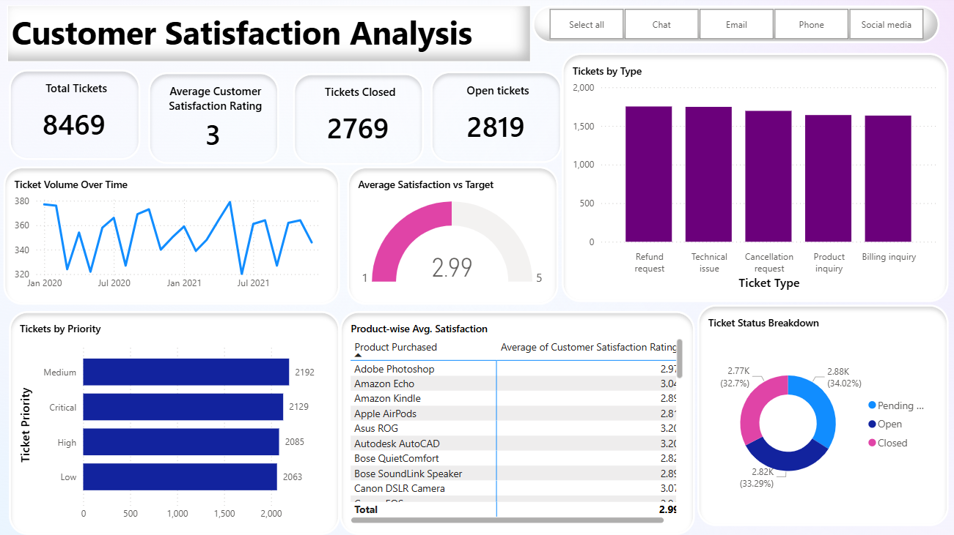

**Key Highlights:**

* **Overall Performance:** Displays total tickets (8,469), tickets closed (2,769), and open tickets (2,819), along with the average customer satisfaction rating (3 out of 5).
* **Ticket Trends:** The *Ticket Volume Over Time* chart shows month-by-month fluctuations, highlighting seasonal or operational workload patterns.
* **Ticket Distribution:** Bar charts visualize tickets by priority and type, revealing a balanced workload with slightly higher counts for *Medium* priority and *Refund requests*.
* **Satisfaction Analysis:** The *Average Satisfaction vs Target* gauge indicates performance just below the target (2.99 vs 3.0), while the *Product-wise Avg. Satisfaction* table identifies specific products with higher or lower ratings.
* **Status Breakdown:** A donut chart clearly illustrates the proportion of tickets that are *Open*, *Closed*, or *Pending Customer Response*, allowing quick identification of bottlenecks.
* **Channel Filters:** Interactive filters (Chat, Email, Phone, Social Media) allow stakeholders to drill down into performance by communication method, supporting more targeted improvements.

**Conclusion:**  
The analysis highlights a generally balanced workload across ticket statuses, priorities, and channels, with no extreme concentration in any single area. However, certain ticket types, particularly *Technical issues*, *Cancellation requests*, and *Refund requests*, exhibit higher volumes of unresolved or pending cases, signaling potential resolution delays and customer follow-up bottlenecks. While satisfaction ratings are moderately consistent across priorities, ticket type plays a more influential role—lower ratings for technical and refund-related cases suggest a need for targeted process improvements. Addressing these areas, alongside resolving data quality issues (e.g., negative resolution times), can enhance overall efficiency and customer experience.